**COMSATS University Islamabad (CUI)**

**Department of Computer Science**

**CSC339- Data Communication and Computer Networks**

**BSE-5B FALL 2021**

**Quiz-1 October 5, 2021**

**____________________________________________________**

**Question 1 (2.5)**

Consider sending a packet from a source host to a destination host over a fixed route. List the delay components in the end-to-end delay. Which of these delays are constant and which are variable?

**Ans:** The delay components are processing delays, transmission delays, propagation delays, and queuing delays. All of these delays are fixed, except for the queuing delays, which are variable.

**Question 2 (2.5)**

Suppose Host A wants to send a large file to Host B. The path from Host A to Host B has three links, 

1. Assume no other traffic in the network, what is the throughput for the file transfer?
2. Suppose the file is 4 million bytes. Dividing the file size by the throughput, how long will it take to transfer the file to Host B?
3. Repeat (a) and (b) , but now with reduced to 100 kbps.

**Ans**: a) 500 kbps b) 64 seconds c) 100kbps; 320 seconds.

**Question 3 (5)**

Consider the figure below, with three links, each with the stated transmission rate and link length. It is assumed that the length of a packet is 4000 bits. The speed of light propagation delay on each link is 3x10^8 m/sec.

Please compute the total end-to-end delay (transmission and propagation delay). Round your answer to two decimals after leading zeros

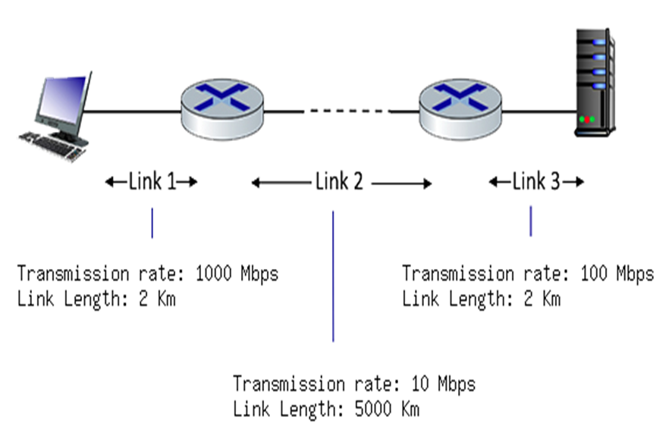

**Ans:**

**Link 1** transmission delay = L/R = 4000 bits / 100 Mbps = 4.0 x10^-5 seconds

**Link 1** propagation delay = d/s = ()3 Km) * 1000 / 3*10^8 m/sec = 1.00E-5 seconds

**Link 1** total delay = d_t + d_p = 4.00E-5 seconds + 1.00E-5 seconds = 5.00E-5 seconds

**Link 2** transmission delay = L/R = 4000 bits / 10 Mbps = 0.0004 seconds

**Link 2** propagation delay = d/s = ()1000 Km) * 1000 / 3*10^8 m/sec = 0.0033 seconds

**Link 2** total delay = d_t + d_p = 0.0004 seconds + 0.0033 seconds = 0.0037 seconds

**Link 3** transmission delay = L/R = 4000 bits / 1000 Mbps = 4.00E-6 seconds

**Link 3** propagation delay = d/s = ()2 Km) * 1000 / 3*10^8 m/sec = 6.67E-6 seconds

**Link 3** total delay = d_t + d_p = 4.00E-6 seconds + 6.67E-6 seconds = 1.07E-5 seconds

**The total delay** = d_L1 + d_L2 + d_L3 = 5.00E-5 seconds + 0.0037 seconds + 1.07E-5 seconds = 0.0038 seconds